**SMART ATTENDANCE**

**A MINOR PROJECT PHASE - I**

***Submitted by***

**PRASHANT SHUKLA (RA1711004020161)**

**RIPUNJOY MADHAB BUDDHA (RA1711004020176)**

**HARSH SRIVASTAVA (RA1711004020181)**

**SHANTANU KAUSHIK (RA1711004020206)**

*in partial fulfilment for the award of the degree of*

**B.Tech.**

*in*

**ELECTRONICS AND COMMUNICATION ENGINEERING**



**SRM INSTITUTE OF SCIENCE AND TECHNOLOGY**

RAMAPURAM

**November,2019**

**SRM INSTITUTE OF SCIENCE AND TECHNOLOGY**

**RAMAPURAM**

**BONAFIDE CERTIFICATE**

Certified that this minor project “**SMART ATTENDANCE**” is the bonafide work of “PRASHANT SHUKLA (RA1711004020161), RIPUNJOY MADHAB BUDDHA (RA1711004020176), HARSH SRIVASTAVA (RA1711004020181), SHANTANU KAUSHIK (RA1711004020206)” who carried out the project work under my supervision.

|  |  |
| --- | --- |
| SIGNATURE  **Dr. Phani Kumar Polasi.**  Professor and Head  Department of Electronics and Communication  Engineering  SRM Institute of Science and Technology  Ramapuram  Chennai-600089 | SIGNATURE  **Dr. Phani Kumar Polasi.**  Professor and Head  Department 0f Electronics and Communication  Engineering  SRM Institute of Science and Technology  Ramapuram  Chennai-600089 |

**INTERNAL EXAMINER- I INTERNAL EXAMINER – II**

**ACKNOWLEDGEMENT**

* We are place on regard our deep sense of gratitude to our beloved Chancellor to **Dr.T.R. PACHAMUTHU,** for providing us with the requisite infrastructure throughout the course.
* We take the opportunity to extend our hearty thanks to our Chairman, **Dr .R. SHIVAKUMAR** for his constant encouragement.
* We take the opportunity to extend our hearty thanks to our Director E&T, **Dr. V. SUBBIAH BHARATHI** for his constant encouragement.
* We take the opportunity to extend our hearty thanks to our Dean,

**Dr. G.Selva Kumar** for his constant encouragement.

* We convey our sincere thanks to our Vice Principal (Academic),

**Dr**. **K.N. SRINIVAS** for his interest and support throughout this project.

* We take the privilege to extend our hearty thanks to the Head of the Department **Dr. PHANI KUMAR POLASI,** for his suggestions, support and encouragement towards the completion of the project with perfection.
* We express our heartfelt thanks to our faculty coordinator  **Dr. PHANI KUMAR POLASI**, **HOD** – Department of Electronics and Communication Engineering for his sustainedencouragement, consecutive criticisms and Support throughout this project work.

**TABLE OF CONTENTS**

|  |  |  |
| --- | --- | --- |
| **CHAPTER NO.** | **TITLE** | **PAGE NO.** |
|  | **ACKNOWLEDGEMENT**  **LIST OF FIGURES**  **ABSTRACT** | **II**  **IV**  **V** |
| **1.** | **INTRODUCTION** | **1** |
| **2.** | **LITERATURE REVIEW**  **2.1-**Literature Review  **2.2-**Existing Method  **2.3-**Proposed Method |  |
| **3.** | **COMPONENTS & SOFTWARE MODULE**  **3.1**-standalone computer needs to be insatlled  **3.2-**Raspberry Pi 3 Model B  **3.3-**Raspberry Pi Camera Module  **3.4-**Open CV  **3.5-**Python 3 |  |
| **4.** | **METHODOLOGY**  **4.1-**OPERATION  **4.2-** ALGORITHM & CODE  **4.3-**HAAR CASCADE CLASSIFIER |  |
| **5.** | **RESULT** |  |
| **6.** | **CONCLUSION** |  |
| **7.** | **REFERENCES** |  |

**LIST OF FIGURES**

|  |  |  |
| --- | --- | --- |
| **FIGURE NO.** | **TITLE** | **PAGE NO.** |
| **3.1** | Raspberry Pi 3 Model B |  |
| **3.2** | Raspberry Pi Camera Module |  |
| **3.3** | OpenCV |  |
| **3.4** | Python 3 |  |
| **4.1** | System Architecture |  |
| **4.2** | Pixel Classification |  |
| **4.3** | Test Image |  |
| **5.1** | Output |  |

**ABSTRACT**

Attendance is always an issue in every class. It is time consuming and often leads to conflicts between students and teachers when it is taken manually. Teachers can also do mistakes while uploading the attendance. So, it is concluded that manual attendance is not favourable option in colleges and universities. The process of attendance can be modified and can be brought into practice. The smart attendance project is able to solve all the problems related to attendance. The smart attendance project is based on image processing .It basically scan the students in the class two times, once in the starting of the class hour and second time in the last 15min. It will scan the face of each and every student in the class and identify the faces and compare it with the stored data in it. If the faces that the camera has scanned matches with the data the student will be marked present in the class and if any face is missing that particular student will be marked absent. This data is then sent to the respective teachers through a message. The process of attendance can be modified and can be brought into practice . The smart attendance project is able to solve all the problems related to attendance. The smart attendance project is based on image processing .It basically scan the class every hour , identify students and make decision either the student is present or absent . This data is then sent to the respective teachers and they can receive the attendance through message .

**KEYWORDS:** Facial Recognition, Attendance

**CHAPTER-1**

**INTRODUCTION**

Face recognition is an important application of Image processing owing to its use in many fields. Identification of individuals in an organization for the purpose of attendance is one such application of face recognition. Maintenance and monitoring of attendance records plays a vital role in the analysis of performance of any organization. The purpose of developing attendance management system is to computerize the traditional way of taking attendance. Automated Attendance Management System performs the daily activities of attendance marking and analysis with reduced human intervention. The prevalent techniques and methodologies for detecting and recognizing face fail to overcome issues such as scaling, pose, illumination, variations, rotation, and occlusions. The proposed system aims to overcome the pitfalls of the existing systems and provides features such as detection of faces, extraction of the features, detection of extracted features, and analysis of students' attendance. The system integrates techniques such as image contrasts, integral images, color features and cascading classifier for feature detection. The system provides an increased accuracy due to use of a large number of features (Shape, Colour, LBP, wavelet, Auto-Correlation) of the face. Faces are recognized using Euclidean distance and k-nearest neighbour algorithms. Better accuracy is attained in results as the system takes into account the changes that occur in the face over the period of time and employs suitable learning algorithms. The system is tested for various use cases. We consider a specific area such as classroom attendance for the purpose of testing the accuracy of the system. The metric considered is the percentage of the recognized faces per total number of tested faces of the same person. The system is tested under varying lighting conditions, various facial expressions, presence of partial faces (in densely populated classrooms) and presence or absence of beard and spectacles. An increased accuracy (nearly 100%) is obtained in most of the cases considered

**OBJECTIVES**

* Detection of unique face image amidst the other natural components such as walls, backgrounds etc.

* Extraction of unique characteristic features of a face useful for face recognition.
* Detection of faces amongst other face characters such as beard, spectacles etc.
* Automated update in the database without human intervention

**CHAPTER-2**

**LITERATURE REVIEW**

**2.1 Literature Review**

Automatic Attendance System Using Deep Learning system by Aryal Rachhpal Singh, Arnav Sood , Gaurav Thapa have integrated facial recognition algorithm with machine learning algorithm into the process of automatic attendance system. This system is implemented in basic and fundamental principle on the presence of a digital camera in the classroom. The digital camera would capture 2 images in the time interval of 25 minutes in a lecture of 50 minutes. If face exists on current database then the system would save unique ID of a student in attendance database or discards in case student doesn’t exist in classroom database. In this paper, they have addressed various problems such as real-time face detection, multiple face detection and integration with the machine learning algorithm. During the implementation of an idea, the real problem was the extraction of a face from the image in real time. (1)

The principal of component analysis (PCA) for face recognition is yet another approach for automatic attendance system using deep learning by Sumeet Kewalramani. This algorithm is the combination of RGB and HSV algorithm. The efficiency of this methhod is more when single face in a given image is taken into consideration. In case of more than one face, the acquired input image may result in detection of some false faces. (2)

1-Sunil Aryala, Rachhpal Singh , Arnav Sood . Automatic Attendance System Using Deep Learning. International Conference on Sustainable Computing in Science, Technology & Management SUSCOM- 22 February 2019.

2-Sumeet Kewalramani, AUTOMATIC ATTENDANCE SYSYTEM BY FACE RECOGNITION USING MACHINE LEARNING INTERNATIONAL JOURNAL OF ENGINEERING SCIENCES & RESEARCH TECHNOLOGY, ISSN: 2277-9655 [Kewalramani * et al.,7(10): October, 2018] Impact Factor: 5.164 IC™ Value: 3.00 CODEN: IJESS7

In Nandhini R system, a computer system will be able to find and recognize human faces fast and precisely in images or videos that are being captured through a surveillance camera. Numerous algorithms and techniques have been developed for improving the performance of face recognition but the concept to be implemented here is Deep Learning. It helps in conversion of the frames of the video into images so that the face of the student can be easily recognized for their attendance so that the attendance database can be easily reflected automatically. It is a neat and hassle free method.

Nandhini R, Duraimurugan N, S.P.Chokkalingam. Face Recognition Based Attendance System. International Journal of Engineering and Advanced Technology (IJEAT) ISSN: 2249 – 8958, Volume-8, Issue-3S, February 2019

**2.2 EXISTING SYSTEMS**

**Fingerprint Based recognition system**

In the Fingerprint based existing attendance system, a portable fingerprint device need to be configured with the students fingerprint earlier. Later either during the lecture hours or before, the student needs to record the fingerprint on the configured device to ensure their attendance for the day. The problem with this approach is that during the lecture time it may distract the attention of the students.

**RFID(Radio Frequency Identification) Based recognition system**

In the RFID based existing system, the student needs to carry a Radio Frequency Identity Card with them and place the ID on the card reader to record their presence for the day. The system is capable of to connect to RS232 and record the attendance to the saved database. There are possibilities for the fraudulent access may occur. Some are students may make use of other students ID to ensure their presence when the particular student is absent or they even try to misuse it sometimes.

**Iris Based Recognition System**

In the Iris based student attendance system, the student needs to stand in front of a camera, so that the camera will scan the Iris of the student. The scanned iris is matched with data of student stored in the database and the attendance on their presence needs be updated. This reduces the paper and pen workload of the faculty member of the institute. This also reduces the chances of proxies in the class, and helps in maintaining the student records safe. It is a wireless biometric technique that solves the problem of spurious attendance and the trouble of laying the corresponding network.

**Face Based Recognition System**

The facial recognition technology can be used in recording the attendance through a high-resolution digital camera that detects and recognizes the faces of the students and the machine compares the recognized face with students’ face images stored in the database. Once the face of the student is matched with the stored image, then the attendance is marked in attendance database for further calculation. If the captured image doesn't match with the students' face present in the database then this image is stored as a new image onto the database. In this system, there are possibilities for the camera to not to capture the image properly or it may miss some of the students from capturing.

**2.3 PROPOSED SYSTEM**

In this system, we have integrated facial recognition algorithm with machine learning algorithm into the process of automatic attendance system. This system is implemented in basic and fundamental principle on the presence of a digital camera in the classroom. The digital camera would capture images in the time interval of 25 minutes in a lecture of 50 minutes. Now image would be provided to system and system would extract all the faces from the image. Now face would be compared with the existing trained model of faces and checks if face exists or not. If face exists on current database then the system would save unique ID of a student in attendance database or discards in case student doesn’t exist in classroom database

**CHAPTER-3**

**COMPONENTS & SOFTWARE MODULE**

**3.1 Standalone computer needs to be installed in the office room where the system is to be deployed :**

Standard equipment and software need to installed in the computer which should have efficient storage in it so that all of the pictures and templates of the students or employee can be stored.

The device should not run out of the storage space as there will be new entries of students or employee every year.

**3.2 Raspberry Pi 3 Model B :**

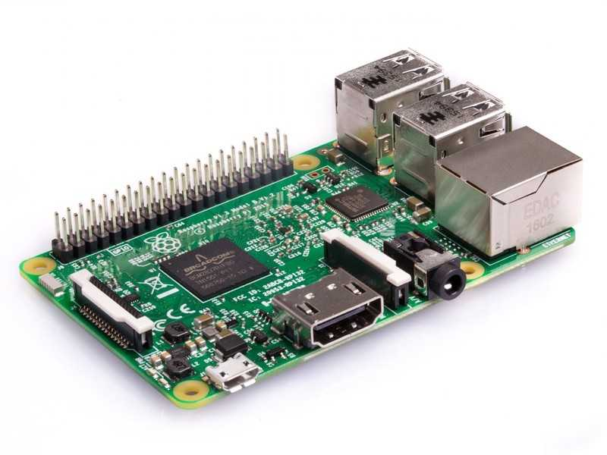

fig:3.1

The Raspberry Pi just got juicer! Now with a Quad-Core 64bit CPU, WiFi & Bluetooth!

The Raspberry Pi 3 Model B is the third generation Raspberry Pi. This powerful credit-card sized single board computer can be used for many applications and supersedes the original Raspberry Pi Model B+ and Raspberry Pi 2 Model B.

Whilst maintaining the popular board format the Raspberry Pi 3 Model B brings you a more powerful processor, 10x faster than the first generation Raspberry Pi.

Additionally it adds wireless LAN & Bluetooth connectivity making it the ideal solution for powerful connected designs.

**Raspberry Pi 3 - Model B Technical Specification :**

* Broadcom BCM2387 chipset
* **1.2GHz Quad-Core ARM Cortex-A53**
* **802.11 bgn Wireless LAN and Bluetooth 4.1** (Bluetooth Classic and LE)
* **1GB RAM**
* **64 Bit CPU**
* 4 x USB ports
* 4 pole Stereo output and Composite video port
* Full size HDMI
* 10/100 BaseT Ethernet socketbr
* CSI camera port for connecting the Raspberry Pi camera
* DSI display port for connecting the Raspberry Pi touch screen display
* Micro SD port for loading your operating system and storing data
* Micro USB power source

**Raspberry Pi 3 - Model B Features :**

* Now **10x Faster** - Broadcom BCM2387 ARM Cortex-A53 Quad Core Processor powered Single Board Computer running at 1.2GHz!
* 1GB RAM so you can now run bigger and more powerful applications
* Fully HAT compatible
* 40pin extended GPIO to enhance your “real world” projects.
* Connect a Raspberry Pi camera and touch screen display (each sold separately)
* Stream and watch Hi-definition video output at 1080
* Micro SD slot for storing information and loading your operating systems.
* 10/100 BaseT Ethernet socket to quickly connect the Raspberry Pi to the Internet

**3.3 Raspberry Pi Camera Module :**

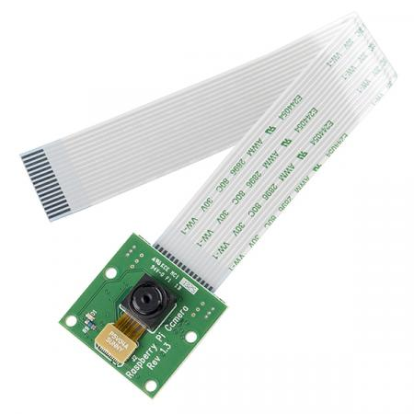

Fig:3.2

The Raspberry Pi Camera v2 is the new official camera board released by the Raspberry Pi Foundation.

The Raspberry Pi Camera Module v2 is a high quality 8 megapixel Sony IMX219 imagesensor custom designed add-on board for Raspberry Pi, featuring a fixed focus lens.

The Raspberry Pi Zero now comes complete with a camera port! Using the new [Raspberry Pi Zero Camera Adapter,](https://thepihut.com/products/raspberry-pi-zero-camera-adapter) you can now use a Raspberry Pi camera to your Zero

It'scapable of 3280 x 2464 pixel static images, and also supports 1080p30, 720p60 and640x480p90 video.

It attaches to Pi by way of one of the small sockets on the board upper surface and uses thededicated CSi interface, designed especially for interfacing to cameras.

**Raspberry Pi Camera Module Features** :

* Fixed focus lens on-board
* 8 megapixel native resolution sensor-capable of 3280 x 2464 pixel static images
* Supports 1080p30, 720p60 and 640x480p90 video
* Size 25mm x 23mm x 9mm
* Weight just over 3g
* Connects to the Raspberry Pi board via a short ribbon cable (supplied)
* Camera v2 is supported in the latest version of Raspbian, Raspberry Pi's prefer operating system

**3.4 OpenCV :**



Fig:3.3

OpenCV (Open Source Computer Vision Library) is an open source computer vision and machine learning software library. OpenCV was built to provide a common infrastructure for computer vision applications and to accelerate the use of machine perception in the commercial products. Being a BSD-licensed product, OpenCV makes it easy for businesses to utilize and modify the code.

The library has more than 2500 optimized algorithms, which includes a comprehensive set of both classic and state-of-the-art computer vision and machine learning algorithms. These algorithms can be used to detect and recognize faces, identify objects, classify human actions in videos, track camera movements, track moving objects, extract 3D models of objects, produce 3D point clouds from stereo cameras, stitch images together to produce a high resolution image of an entire scene, find similar images from an image database, remove red eyes from images taken using flash, follow eye movements, recognize scenery and establish markers to overlay it with augmented reality, etc. OpenCV has more than 47 thousand people of user community and estimated number of downloads exceeding [18 million](https://sourceforge.net/projects/opencvlibrary/files/stats/timeline?dates=2001-09-20+to+2019-01-30). The library is used extensively in companies, research groups and by governmental bodies.

**Support :**

**When something fails**

If you are attempting to debug an OpenCV program:

* At first try to troubleshoot the problem using [documentation](http://docs.opencv.org/) and [tutorials](http://docs.opencv.org/master/d9/df8/tutorial_root.html).
* If it doesn’t help, search for an answer or ask a question at [OpenCV Answers](http://answers.opencv.org/).
* If you found a bug or wish to make a feature request, please see the next section.

**Reporting issues / requesting features :**

* First, check the [issue tracker](https://github.com/opencv/opencv/issues): known bugs, often with patches or workarounds, are generally found there. If you have something to add to an existing bug, add it as a comment to the ticket, rather than posting to the mailing lists.
* Then check the [OpenCV Answers](http://answers.opencv.org/) to see if someone else has asked your question or reported your bug.
* If all the above steps failed, the best thing to do is to raise a [ticket](https://github.com/opencv/opencv/issues/new)

**3.5 Python 3 :**



Fig:3.4

Python is a general-purpose interpreted, interactive, object-oriented, and high-level programming language. It was created by Guido van Rossum during 1985- 1990. Like Perl, Python source code is also available under the GNU General Public License (GPL). Python is named after a TV Show called ëMonty Pythonie Flying Circusí and not after Python-the snake.

Python 3.0 was released in 2008. Although this version is supposed to be backward incompatibles, later on many of its important features have been back ported to be compatible with version 2.7.This tutorial gives enough understanding on Python 3 version programming language. Please refer to for our Python 2 tutorial.

**Characteristics of Python :**

Following are important characteristics of python -

* It supports functional and structured programming methods as well as OOP.
* It can be used as a scripting language or can be compiled to byte-code for building large applications.
* It provides very high-level dynamic data types and supports dynamic type checking.
* It supports automatic garbage collection.
* It can be easily integrated with C, C++, COM, ActiveX, CORBA, and Java.

**CHAPTER-4**

**METHODOLOGY**

**4.1 Operation**

The system consists of a camera that captures the images of the employee and sends it to the image enhancement module. After enhancement the image comes in the Face Detection and Recognition modules and then the attendance is marked on the database server. This is shown in the experimental setup in Figure. At the time of enrolment, templates of face images of individual employees are stored in the Face database. Here all the faces are detected from the input image and the algorithm compares them one by one with the face database.

If any face is recognized the attendance is marked on the server from where anyone can access and use it for different purposes

Fig:4.1

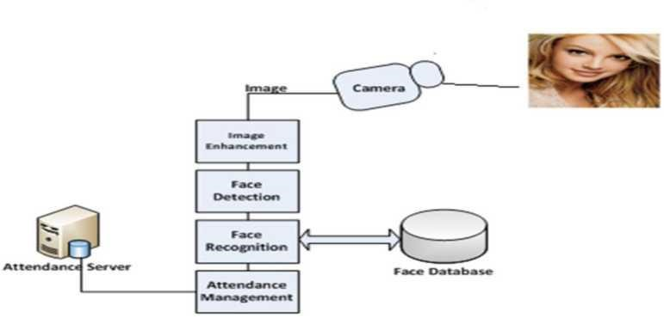

In this way a lot of time is saved and this is highly secure process no one can mark the attendance of other. Attendance is maintained on the server so anyone can access it for purposes like administration, employees themselves. In order to avoid the false detection we are using the skin classification technique . Using this technique enhance the efficiency and accuracy of the detection process.

In this process first the skin is classified and then only skin pixels remains and all other pixels in the image are set to black, this greatly enhance the accuracy of face detection process. Two databases are displayed in the experimental setup. Face Database is the collection of face images and extracted features at the time of enrolment process and the second attendance database contains the information about the employees and also uses to mark attendance

**4.2 SYSTEM ALGORITHM**

* Image acquisition
* Haar cascade classifier

1: Pick a pixel location from the image.

2: Now crop a sub-image with the selected pixel as the center from the source image with the

same size as the convolution kernel.

3: Calculate an element-wise product between the values of the kernel and sub- image.

4: Add the result of the product.

5: Put the resultant value into the new image at the same place where you picked up the pixel

location.

* Face recognition
* Attendance

**4.3 Haar cascade classifier**

The idea of Haar cascade is extracting features from images using a kind of ‘filter’, similar to the concept of the convolutional. These filters are called Haar features and look like that:

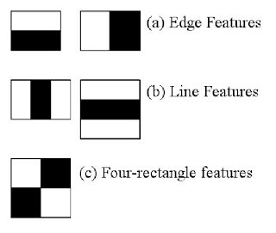

Fig:4.2

The idea is passing these filters on the image, inspecting one portion (or window) at the time. Then, for each window, all the pixel intensities of, respectively, white and black portions are summed. Finally, the value obtained by subtracting those two summations is the value of the feature extracted. Ideally, a great value of a feature means it is relevant. Namely, if we consider the Edge feature (a) and apply it to the following B&W pic

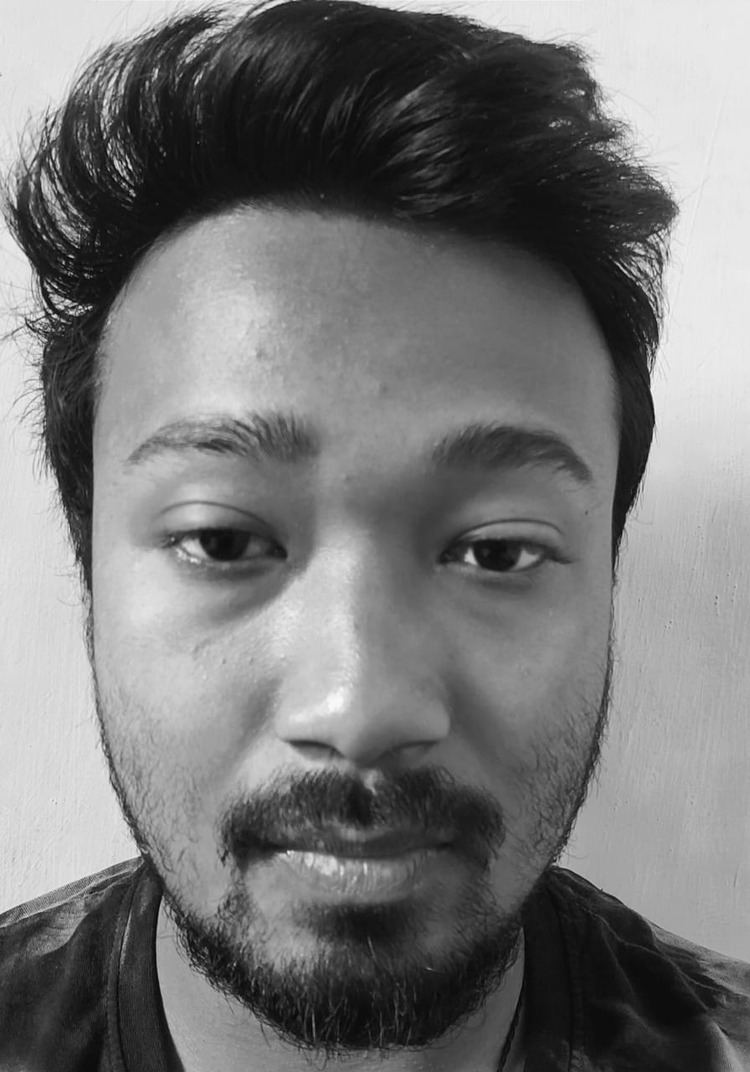

Fig:4.3



We will obtain a significant value, hence the algorithm will return an edge feature with high probability. Of course, the real intensities of pixels is never equal to white or black, and we will often face a similar situation:

Now, imagine the huge amount of features returned by this computation. To give you an idea, even a 24x24 window results over 160000 features, and windows within an image are a lot. How to make this process more efficient? The solution came out with the concept of Summed-area table, also known as Integral Image. It is a data structure and algorithm for generating the sum of values in a rectangular subset of a grid. The goal is reducing the number of computations needed to obtain the summations of pixel intensities within a window.

Next step also involves efficiency and optimization. Besides being numerous, features might also be irrelevant. Among the features we obtain (that are more than 160000), how can we decide which ones are good? The answer to this question relies on the concept of Ensembilg method: by combining many algorithms, weak by definition, we can create a strong algorithm. This is accomplished using Adaboost which both selects the best features and trains the classifiers that use them. This algorithm constructs a “strong” classifier as a linear combination of weighted simple “weak” classifiers.

The last concept which needs to be introduced is a final element of optimization (in terms of the time of training). Indeed, even though we reduced our 160000+ features to a more manageable number, the latter is still high: applying all the features on all the windows will take a lot of time. That’s why we use the concept of Cascade of classifiers: instead of applying all the features on a window, it groups the features into different stages of classifiers and applies one-by-one. If a window fails (translated: the difference between white and black summations is low) the first stage (which normally includes few features), the algorithm discards it: it won’t consider remaining features on it. If it passes, the algorithm applies the second stage of features and continues the process.

Great, now that the concept of Haar Cascade is clearer, let’s dive into some lines of code using Python and the mentioned library OpenCV

* import numpy as np
* import cv2
* face_cascade = cv2.CascadeClassifier("haarcascade_frontalface_default.xml")
* eye_cascade = cv2.CascadeClassifier("haarcascade_eye.xml")
* img = cv2.imread("image.jpg")
* gray = cv2.cvtColor(img, cv2.COLOR_BGR2GRAY)
* faces = face_cascade.detectMultiScale(gray, 1.3, 5)
* for (x,y,w,h) in faces:
* img = cv2.rectangle(img,(x,y),(x+w,y+h),(255,0,0),2)
* roi_gray = gray[y:y+h, x:x+w]
* roi_color = img[y:y+h, x:x+w]
* eyes = eye_cascade.detectMultiScale(roi_gray)
* for (ex,ey,ew,eh) in eyes:
* cv2.rectangle(roi_color,(ex,ey),(ex+ew,ey+eh),(0,255,0),2)
* cv2.imshow('img',img)
* cv2.waitKey(0)
* cv2.destroyAllWindows()

**CHAPTER-5**

**RESULT**

After running the algorithm we got our output of the recognized image

Showing the name of the candidate .

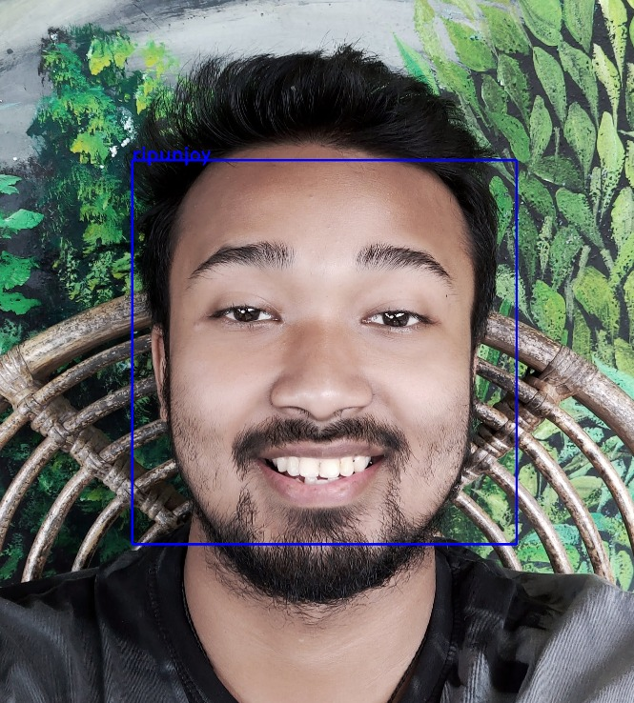

Fig:5.1

**CHAPTER-6**

**CONCLUSION**

Automated Attendance System has been envisioned for the purpose of reducing the errors that occur in the traditional (manual) attendance taking system. The aim is to automate and make a system that is useful to the organization such as an institute. The efficient and accurate method of attendance in the office environment that can replace the old manual methods. This method is secure enough, reliable and available for use. No need for specialized hardware for installing the system in the office. It can be constructed using a camera and computer.

**SCOPE FOR FUTURE WORK**

* the system has reached the accuracy level up to 80% for partial and dense images. It can further be improved to obtain higher accuracy levels
* Multiple Face Being Detected at the same time
* Using multiple algorithm at the same time.
* Compatibility with high resolution camera

**REFERENCE**

1:-Sunil Aryala, Rachhpal Singh , Arnav Sood . Automatic Attendance System Using Deep Learning. International Conference on Sustainable Computing in Science, Technology & Management SUSCOM- 22 February 2019.

2:-Sumeet Kewalramani, AUTOMATIC ATTENDANCE SYSYTEM BY FACE RECOGNITION USING MACHINE LEARNING INTERNATIONAL JOURNAL OF ENGINEERING SCIENCES & RESEARCH TECHNOLOGY, ISSN: 2277-9655 [Kewalramani * et al.,7(10): October, 2018] Impact Factor: 5.164 IC™ Value: 3.00 CODEN: IJESS7

3:- Nandhini R, Duraimurugan N, S.P.Chokkalingam. Face Recognition Based Attendance System. International Journal of Engineering and Advanced Technology (IJEAT) ISSN: 2249 – 8958, Volume-8, Issue-3S, February 2019

4:- N.Sudhakar Reddy, M.V.Sumanth, S.Suresh Babu, "A Counterpart Approach to Attendance and Feedback System using Machine Learning Techniques",Journal of Emerging Technologies and Innovative Research (JETIR), Volume 5, Issue 12, Dec 2018.

5:-Dan Wang, Rong Fu, Zuying Luo, "Classroom Attendance Auto-management Based on Deep Learning",Advances in Social Science, Education and Humanities Research, volume 123,ICESAME 2017.

6:- <https://www.tutorialspoint.com/opencv/index.html>

7:- https://towardsdatascience.com/face-recognition-with-opencv-haar-cascade-a289b6ff042a